DOKUZ EYLUL UNIVERSITY
ENGINEERING FACULTY
DEPARTMENT OF COMPUTER ENGINEERING

CME1251 PROJECT BASED LEARNING – III
PROGRESS REPORT
PROJECT – III

GRAPHER

by
Deniz Korkmaz
Dırahşan Çağrı İrdemez
Mehmet Ali Tanrıkulu

Lecturers
Doç. Dr. Derya Birant
Res. Asst. Göksu Tüysüzoğlu

13.12.2019

CHAPTER ONE
PROGRESS SUMMARY

Work Done
Deniz Korkmaz: Took care of details of the code. Helped make the code easier. Some ideas about solving some problems.

Dırahşan Çağrı İrdemez: Programmed menu system in order to let user choose whether they want to draw a graph or load an existing one. Implemented drawing graph mechanics (putting nodes, deleting, drawing lines and putting an X meaning the head of the line) based on user’s choice. Wrote a function in order to handle matrix multiplications which makes it possible to calculate r(1), r(2), r(n) and r(*) matricies. Also, wrote a function to load a graph.

Mehmet Ali Tanrıkulu: We made drawing graph according to user's entry and pulling from file.

Work in Progress
Deniz Korkmaz: Trying to solve the issue of turning point.

Dırahşan Çağrı İrdemez: Working on tracing algorithm and finding the r(min) matrix.

Mehmet Ali Tanrıkulu: Define exponential matrices.

Work to Be Done
Deniz Korkmaz: Turning Point problems will be solved. R Matricies and R Star matricies will be shown as it’s supposed to be.

Dırahşan Çağrı İrdemez: Visual improvements may be added after meeting the fundamental specifications.

Mehmet Ali Tanrıkulu: Define exponential matrices.

CHAPTER TWO
algorıthms and solutıon strategıes
Deniz Korkmaz: To write matricies variant, wrote a function.Owing to this function we do not have to write every matricies one by one. To draw the main graph and wrote every single value to matricies, he wrote a function. This function provides drawing graph otomatically and regular. Also it provides writing the values of matricies to the matricies properly.

Dırahşan Çağrı İrdemez: In order to develop tracing algorithm, we had to find neighbours of nodes and breakpoints, to accomplish this, a function which takes a location and a 2D matrix graph as argument has been written. The function finds all of the neighbours of the location and returns them as an array.

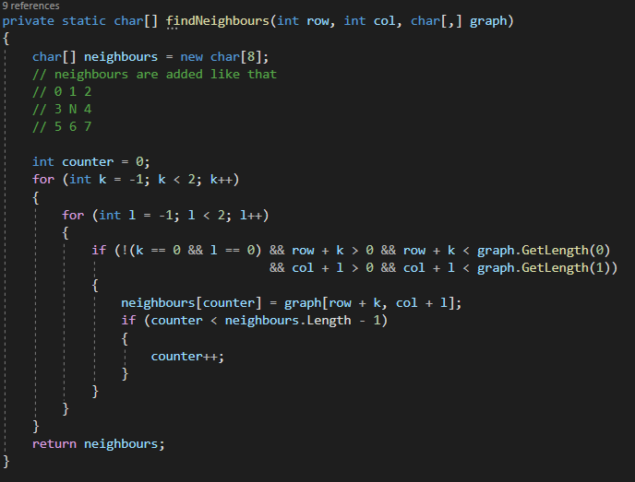

After relation matrix is found, r(n) matricies should have been calculated. In order to accomplish this, a boolean matrix multipication function has been written. Also, this function could have been used for other future projects.

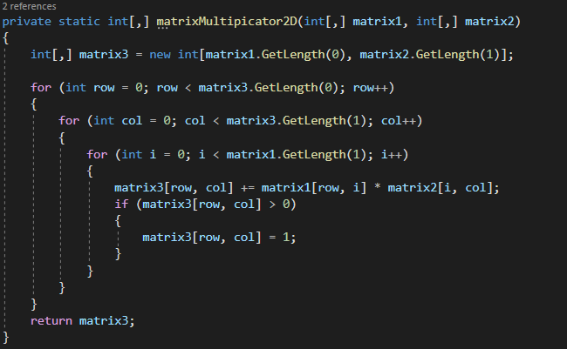

Mehmet Ali Tanrıkulu: We used mostly while/for loops: clean surface,cursor movement etc. , FileStream for pulling graph from file and else/if statements for cursor movements and controlling relation matrices.

CHAPTER THREE
PROBLEMS ENCOUNTERED

Deniz Korkmaz: He offered the idea that making an array to keep the nodes neighbours and use them to tracing.

Dırahşan Çağrı İrdemez: I have encountered a problem about sorting the relation matrix in an alpabethic order but solved it using a built in c# function called Array.Sort(). Also, when building an algorithm for tracing algorithm, I have done it in a half hard coded way. I am planning to solve this by using a different method for moving and checking the index point.

Mehmet Ali Tanrıkulu: We don't face any problems just a little bit difficulty in relation matrices.

